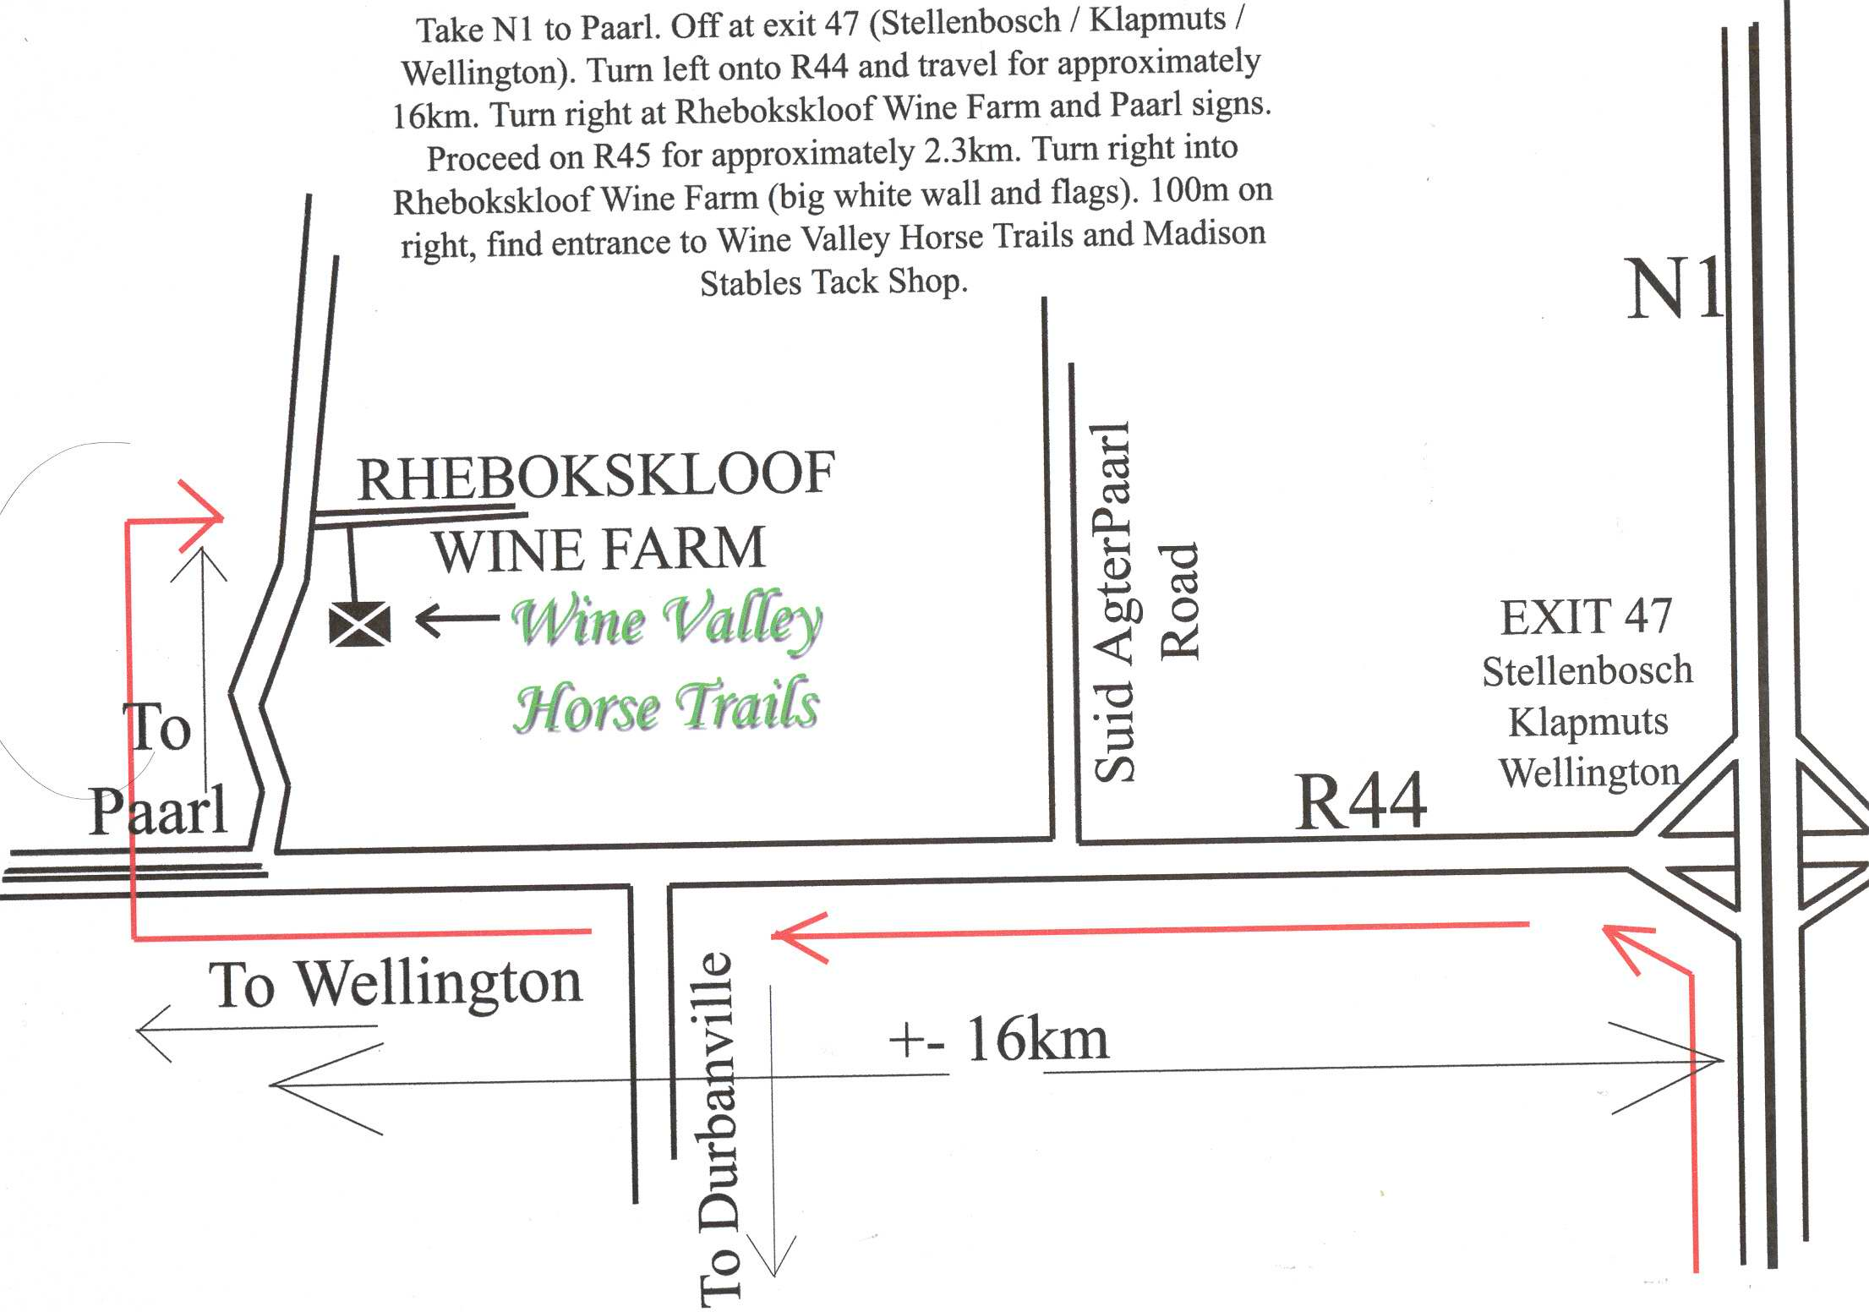

Contact: Michelle 083 226 8735 or 083 657 5135
Address: Rhebokskloof Wine Farm
Noord Agter Paarl Road, Windmeul Paarl

